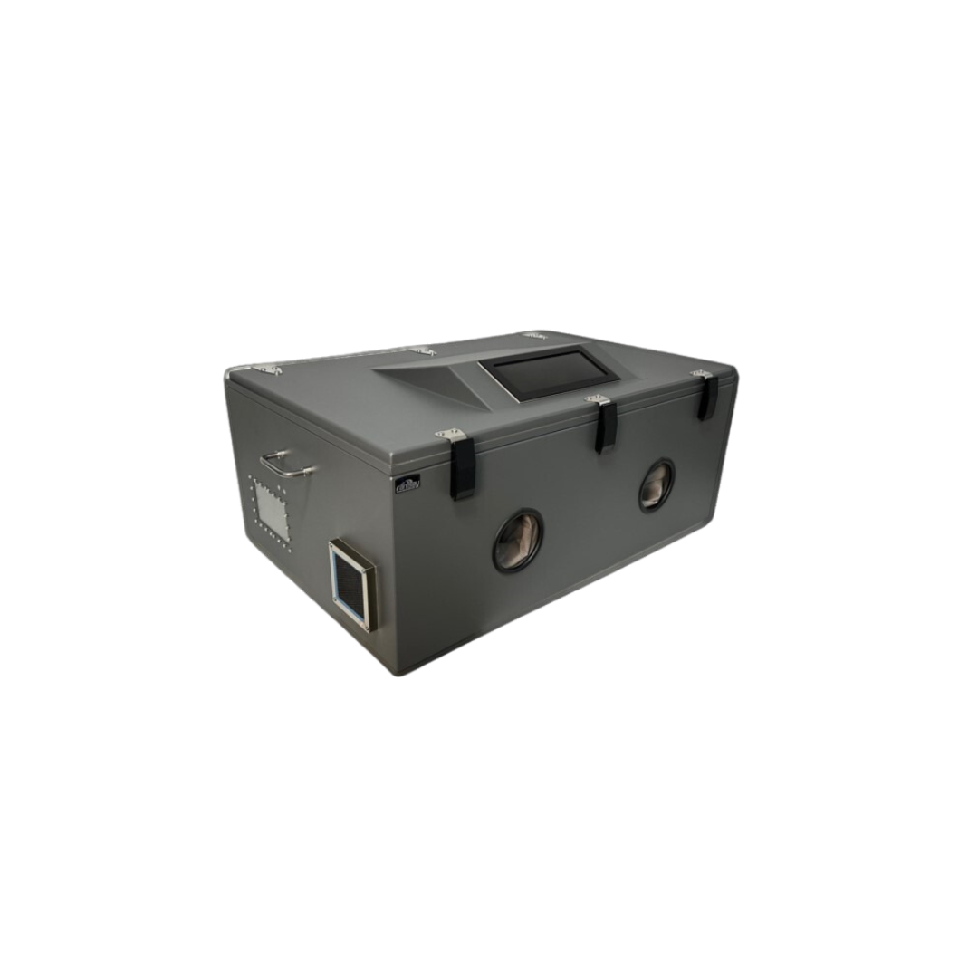

STE6000
Key Features
Included Interface Options
None
Included Power
6 Outlet 120VAC Power Strip
Included Ventilation
120MM Honeycomb Vents
I/O Plates Included
3
Loading Style
TOP
Warranty
1 YEAR
Category
BENCH TOP
Absorber/foam
3/4" INSERTION LOSS
External Dimensions
37.5"(W) X 24.9"(D) X 17.4"(H)
Internal Dimensions
34.2"(W) X 22.2"(D) X 12.6"(H)
Shipping Requirements
Must Ship on A Pallet
Approx. Shipping Weight
100lbs
Shielding Effectiveness (dB)
Isolation At 2.4GHz
>85dB
Isolation At 5.8GHz
>80dB

INCLUDES THE FOLLOWING FEATURES:

•6 Outlet 120VAC Power Strip
•6 Pole Filtered Terminal Block feedthrough
•RF tight viewing window
•(2) ULTRA HIGH ISOLATION FLEXIBLE GLOVES GEN-3
•Designed for a wide variety of RF testing, function/s determined by user customization.
•Perfect for (Wi-Fi 4, 5, 6, 6E (802.11a/b/g/n/ac/ax)
•Wireless device testing
•Bluetooth, RFID, 3G, 4G, 5G testing
•Totally customizable with a wide variety of I/O options available

The STE6000 is a blank enclosure ready to be customized to match your specific RF testing requirements. Our Engineering team is available to assist you to make sure your custom enclosure is designed to meet your unique RF testing requirements. This enclosure does incorporate a 120mm passive ventilation system with optional 12 volt DC, 115 VAC, or 230VAC fans available. As with all of our enclosures, your custom I/O configuration is brought out to a precision machined I/O panel, giving you off the shelf delivery of your custom order.

Features:
•Designed for WLAN testing
•Top loading swing away door
•Dual ventilation standard or fan forced cooling optional.
•Exclusive double lip RF tight gasket
•Universal I/O connector interface plate
•Insertion Loss RF absorbent foam liner Standard
•Reflection Loss solutions available
•Optional security locking latch available
Isolation (Base Enclosure, may vary depending on I/O or options selected in final configuration):

•>85dB to 3GHz
•>80dB to 6GHz

I/O Connectors:
•See options for off-the-shelf connectors/interfaces available.
•Coaxial connectors: SMA, BNC, TNC, N, N to SMA, etc..
•Digital interfaces: USB, Ethernet, Video, Serial, Audio, Fiber, etc..
•Power filter interface: AC and DC
•Power Strip Options: US, UK, European, France, Swiss, Italy, Israel, India, China, Australia, Multi Country Config, etc…
•Custom connection options can be sourced through our Engineering

