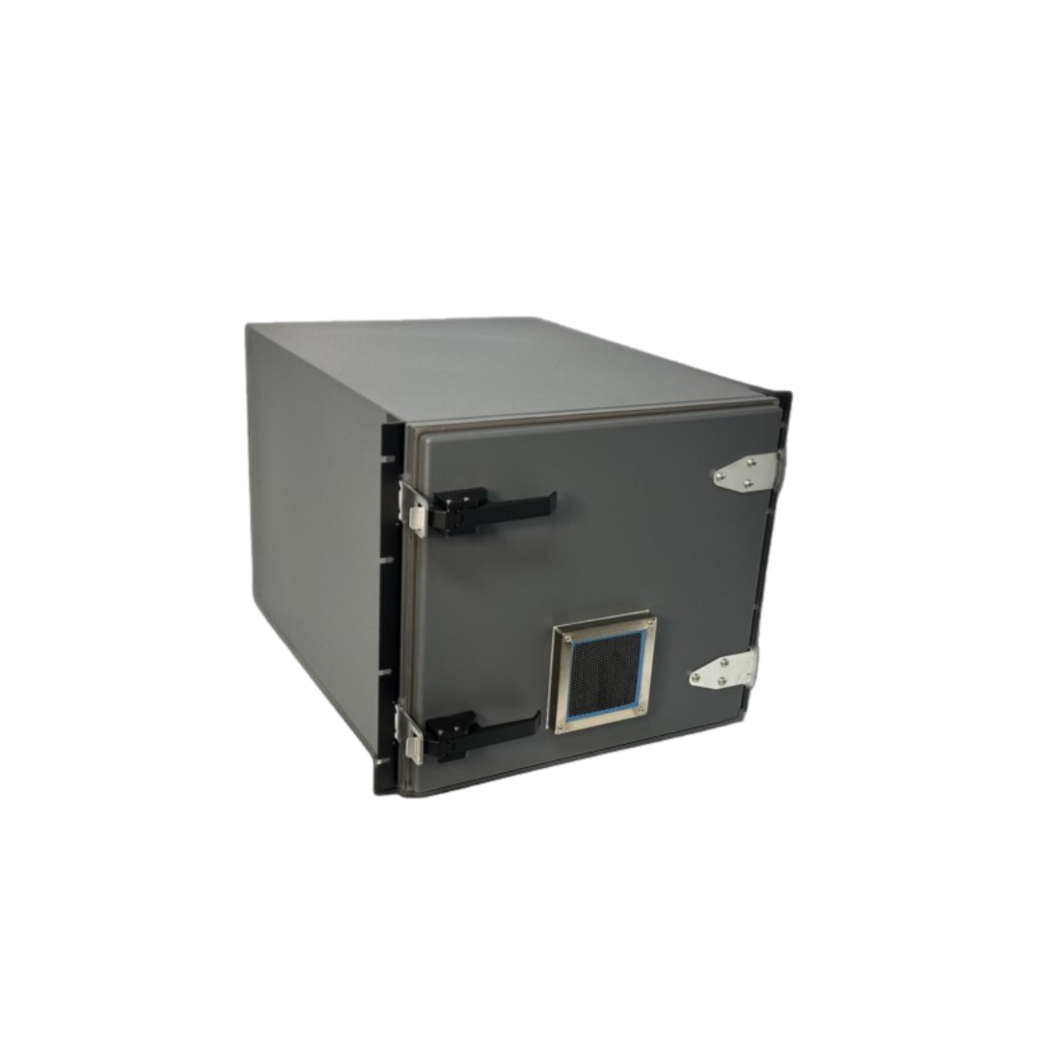**Key Features STE4450**

**Included Interface Options**

None

**Included Power**

None

**Included Ventilation**

120MM Honeycomb Vents

I/O Plates Included

1

**Loading Style**

FRONT

**Warranty**

1 YEAR

**Category**

RACK MOUNTED

**Rack Units**

9RU

**Absorber/foam**

3/4" INSERTION LOSS

**External Dimensions**

19.0"(W) X 24.6"(D) X 15.8"(H)

**Internal Dimensions**

15.3(W) X 20.7"(D) X 13.6"(H)

**Shipping Dimensions**

33"(W) X 24"(D) X 21"(H)

**Approx. Shipping Weight**

55lbs

**Shielding Effectiveness (dB)**

Isolation At 2.4GHz

>95dB

Isolation At 5.8GHz

>90dB

**(NO OPTIONS INCLUDED, fully customizable to your requirements)**

•Designed for a wide variety of RF testing, function/s determined by user customization.

•Perfect for (Wi-Fi 4, 5, 6, 6E (802.11a/b/g/n/ac/ax)

•Wireless device testing

•Bluetooth, RFID, 3G, 4G, 5G testing

•Totally customizable with a wide variety of I/O options available

The STE4450 is a blank enclosure ready to be customized to match your specific RF testing requirements. Our Engineering team is available to assist you to make sure your custom enclosure is designed to meet your unique RF testing requirements. The STE4450 can be used as a standalone enclosure or use the included brackets for mounting into a standard 19-inch rack system. This enclosure also incorporates a 120mm passive ventilation system standard with optional 12-volt DC, 115 VAC, or 230VAC fans available. As with all our enclosures, your custom I/O configuration is brought out to a precision machined I/O panel, giving you off the shelf delivery of your custom order.

**Features:**

•Designed for WLAN testing

•Front loading swing away door

•Dual ventilation standard or fan forced cooling optional.

•Exclusive double lip RF tight gasket

•Universal I/O connector interface plate

•Insertion Loss RF absorbent foam liner Standard

•Reflection Loss solutions available

•Optional security locking latch available

Isolation (Base Enclosure, may vary depending on I/O or options selected in final configuration):

•>95dB to 2.4GHz

•>90dB to 5.8GHz

**I/O Connectors:**

•None provided standard, customized to your specific requirements.

•See options for off-the-shelf connectors/interfaces available.

•Coaxial connectors: SMA, BNC, TNC, N, N to SMA, etc..

•Digital interfaces: USB, Ethernet, Video, Serial, Audio, Fiber, etc..

•Power filter interface: AC and DC

•Power Strip Options: US, UK, European, France, Swiss, Italy, Israel, India, China, Australia, Multi Country Config, etc…

•Custom connection options can be sourced through our Engineering Team.