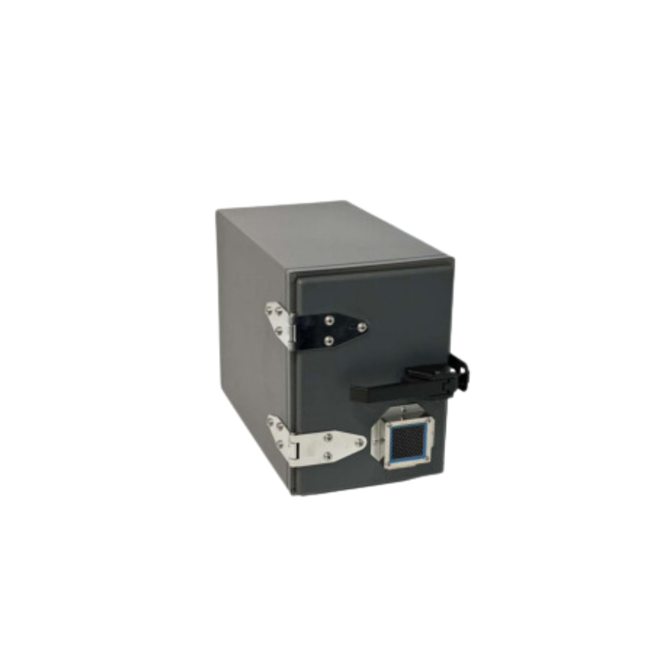
Key Features STE2905M
Included Interface Options
None
Included Power
None
Included Ventilation
60MM Honeycomb Vents
I/O Plates Included
One
Loading Style
FRONT
Warranty
Limited 1 YEAR
Category
BENCH TOP
Absorber/foam
3/4" Carbon Impregnated
External Dimensions
8.7"(W) X 20.6"(D) X 12.1"(H)
Internal Dimensions
6.2"(W) X 16.8"(D) X 9.9"(H)
Approx. Shipping Weight
N/A
Shielding Effectiveness (dB)
Isolation At 2.4GHz
>95dB
Isolation At 5.8GHz
>90dB

The STE2905M is a blank enclosure ready to be customized to match your specific RF testing
requirements. Our Engineering team is available to assist you to make sure your custom enclosure is
designed to meet your unique RF testing requirements. This enclosure does incorporate a 60mm passive
ventilation system with optional 12-volt DC, 115 VAC, or 230VAC fans available. As with all of our enclosures, your custom I/O configuration is brought out to a precision machined I/O panel, giving you
off-the-shelf delivery of your custom order.

(NO OPTIONS INCLUDED, fully customizable to your requirements)
- Designed for a wide variety of RF testing, function/s determined by user customization.
- Perfect for (Wi-Fi 4, 5, 6, 6E (802.11a/b/g/n/ac/ax)
- Wireless device testing
- Bluetooth, RFID, 3G, 4G, 5G testing
- Totally customizable with a wide variety of I/O options available

FEATURES
- Designed for WLAN testing
- Front loading swing away door
- Dual ventilation or fan forced cooling
- Exclusive double lip RF tight gasket
- Universal I/O connector interface plate
- RF absorbent foam liner
- Optional security locking latch available
- Isolation (Base Enclosure, may vary depending on I/O or options selected in final configuration):

None provided standard, customized to your
specific requirements.
- See options for off-the-shelf connectors/interfaces available.
- Coaxial connectors: SMA, BNC, TNC, N, N to SMA, etc..
- Digital interfaces: USB, Ethernet, Video, Serial, Audio, Fiber, etc..
- Power filter interface: AC and DC
- Power Strip Options: US, UK, European, France, Swiss, Italy, Israel, India, China, Australia,
- Multi Country Config, etc…
Custom connection options can be sourced through our Engineering Team.

